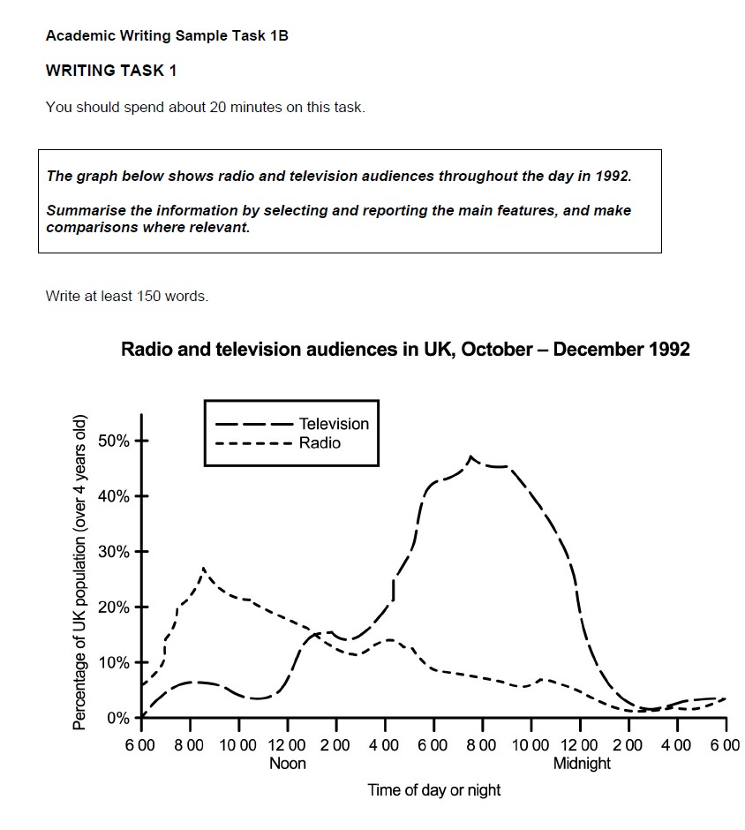
Academic Writing Sample Task

Academic Writing, describing data (IELTS Task 1): Worksheet 1

- In summary, the radio audience is bigger in the morning because people listen to the radio in their cars on the way to work, and the TV audience is bigger in the evening because people prefer watching television as a way of relaxing.

- In conclusion, we can say that radio audience figures peak at just under 30% in the mornings, while the television audience hits a high of 45% in the evenings.

- To sum up, overall more people watch television than listen to the radio. The radio is more popular in the morning, whereas the television has a significantly larger audience in the evening.

……………………………………….. fold here ……………………………………………………………

To sum up In conclusion In summary | overall | more people watch television than listen to the radio.
(Box 1)  The radio is more popular in the morning |  | , whereas  , but  , while
the television has a | significantly  (Box 3) | (Box 2)  larger number of viewers in the evening.
(Box 3)
substantially
generally speaking
. In contrast
in general
slightly
. On the other hand
. However

Between 1) and 2) there is a sharp rise from approximately 3) % to a peak of just under 4)
%.

It stays at about 5) % until just before 6) when it shoots up rapidly to its peak of 7) %.

It remains at roughly the same level until 8) when it sees a rapid decrease in numbers until it reaches its lowest point of 9) % at 10) .

The audience figure rises steadily from 11) to 12) , then falls briefly at 13) before jumping to 14)
% at 15) .

This figure experiences a gradual decline to 16) % over the rest of the day, although there is a slight increase at around17) and again at 18) .

……………………………………….. fold here ……………………………………………………………

It sees from % to %.
ADJECTIVE
NOUN
sharp
rise

It experiences There is
a/an
to a peak of %.

until it reaches its lowest point of %.

The figure/ number/ percentage
from % to %. to a peak of %.
until it reaches its lowest point of
VERB
ADVERB
rises
steadily
%.

.

ANSWER KEY: Academic Writing, describing data (IELTS Task 1): Worksheet 2

Between 1) 6.00 a.m. and 2) 8.00 a.m. there is a sharp rise from approximately 3) 7% to a peak of just under 4) 30%. (Radio)

It stays at about 5) 15% until just before 6) 4.00 p.m. when it shoots up rapidly to its peak of 7) 45%. (TV)

It remains at roughly the same level until 8) 10 p.m. when it sees a rapid decrease in numbers until it reaches its lowest point of 9) 2% at 10) 2 a.m. (TV)

The audience figure rises steadily from 11) 6.00 a.m. to 12) 8.00 a.m., then falls briefly at 13) 10.00 before jumping to 14) 15% at 15) 2.00 p.m. (TV)

This figure experiences a gradual decline to 16) 2% over the rest of the day, although there is a slight increase at around 17) 4.00 p.m. and again at 18) 10 p.m. (Radio)

……………………………………….. fold here ……………………………………………………………

It sees  It experiences There is | a/an | ADJECTIVE  sharp  rapid gradual slight | NOUN  rise  decrease decline increase | from % to %.  to a peak of %.  until it reaches its lowest point of %.

The figure/ number/ percentage | VERB  rises  shoots up falls | ADVERB  steadily  rapidly briefly | from % to %. to a peak of %.  until it reaches its lowest point of %

Academic Writing, describing data (IELTS Task 1): Worksheet 3A

Student A

Introduction
Radio
TV
Summary

Academic Writing, describing data (IELTS Task 1): Worksheet 3B

Student B

Introduction
Morning (Radio, then TV)
Afternoon (Radio, then TV)
Evening (Radio, then TV)
Summary

